Supplementary Figure1: Annotation Module applied to real data. Metabolite data present a very heterogeneous structure in terms of naming. A set of text mining rules were developed to match the maximum number of terms possible to the unique nomenclature of the KEGG database. For a rat dataset, 26% of the metabolites were matched using conventional approaches. Our novel text mining approach maps 95 % of terms KEGG nomenclature. Note that some of these terms do not have associated KEGG Pathways (Panel A). As abbreviations of terms are common in this kind of data, one solution to match as many terms as possible is to find out the scientific name for each term. Also, removing common chemical words, prefixes and suffixes can improve the percentage of matched terms (Panel C). Panel C shows an example of the output of this Annotation Module, where the name in KEGG and the KEGG ID is returned for each input metabolite name, accompanied by the similarity score for matching to KEGG, information about the ties (Tie = Yes indicates cases with the same similarity) and if those metabolites have been selected by the algorithm or not. Additional examples about the founded KEGG Pathways are appended as well. KEGG database has a bad resolution for lipids (e.g. it cannot differentiate between types of sphingomyelins). In these cases, the same KEGG Identifier is given for multiple lipids (Panel D).

Assigning a KEGG ID, KEGG Name and KEGG Pathway. Metabolites / small molecules are referred to by a large number of names and abbreviations, some of these depend on the database used. In (many) cases an experiment cannot unambiguously identify and name a metabolite, instead only determine a metabolite “class”. To assign KEGGIDs to metabolites / metabolite classes identified in an experiment, a set of text mining rules was developed to match experiment names to unique compound names in the KEGG database. This approach maximizes the number of terms in common. After an initial attempt at a full name match, experiment names are simplified using the following procedure. Common metabolite prefixes are removed (cis-, trans-, d- , l- , (s)-, alpha-, beta-, alpha, beta, alpha-d-, beta-d-, alpha-l-, beta-l-, l-beta-, l-alpha-, d-beta-, d-alpha-). If the metabolite name given is an acid, then the name is modified to the conjugate base by replacing “ic acid”, “icacid” or “ic_acid” with “ate”. If amino acids are given in 1-letter or 3-letter abbreviations, names are modified to the full amino acid name. The following commonly used lipid abbreviations are modified to reflect the full names (SM = sphingomyelin, lysopc = lysophosphatidylcholine, PC = phosphatidylcholine, PE = phosphatidylethanolamine and LysoPE = lysophosphatidylethanolamine). Similarly, abbreviations for other commonly assayed metabolites are modified to reflect the full names (cit = citrate, orn = ornithine, thyr = thyroxine and boc = butoxycarbonyl). Each parsed metabolite name is compared to metabolite names in KEGG. The best match in KEGG is identified based on the longest contiguous matching subsequence that does not contain 'junk' elements where 'junk' elements are defined as duplicates making up more than 1% of a sequence with minimum length of 200 (python SequenceMatcher class from difflib). Note that the experimental metabolite names and information about any ties are retained in the output dataset for manual curation. This procedure increases the number of matches between experimental metabolites and metabolites in KEGG (Supplemental Figure 1A).

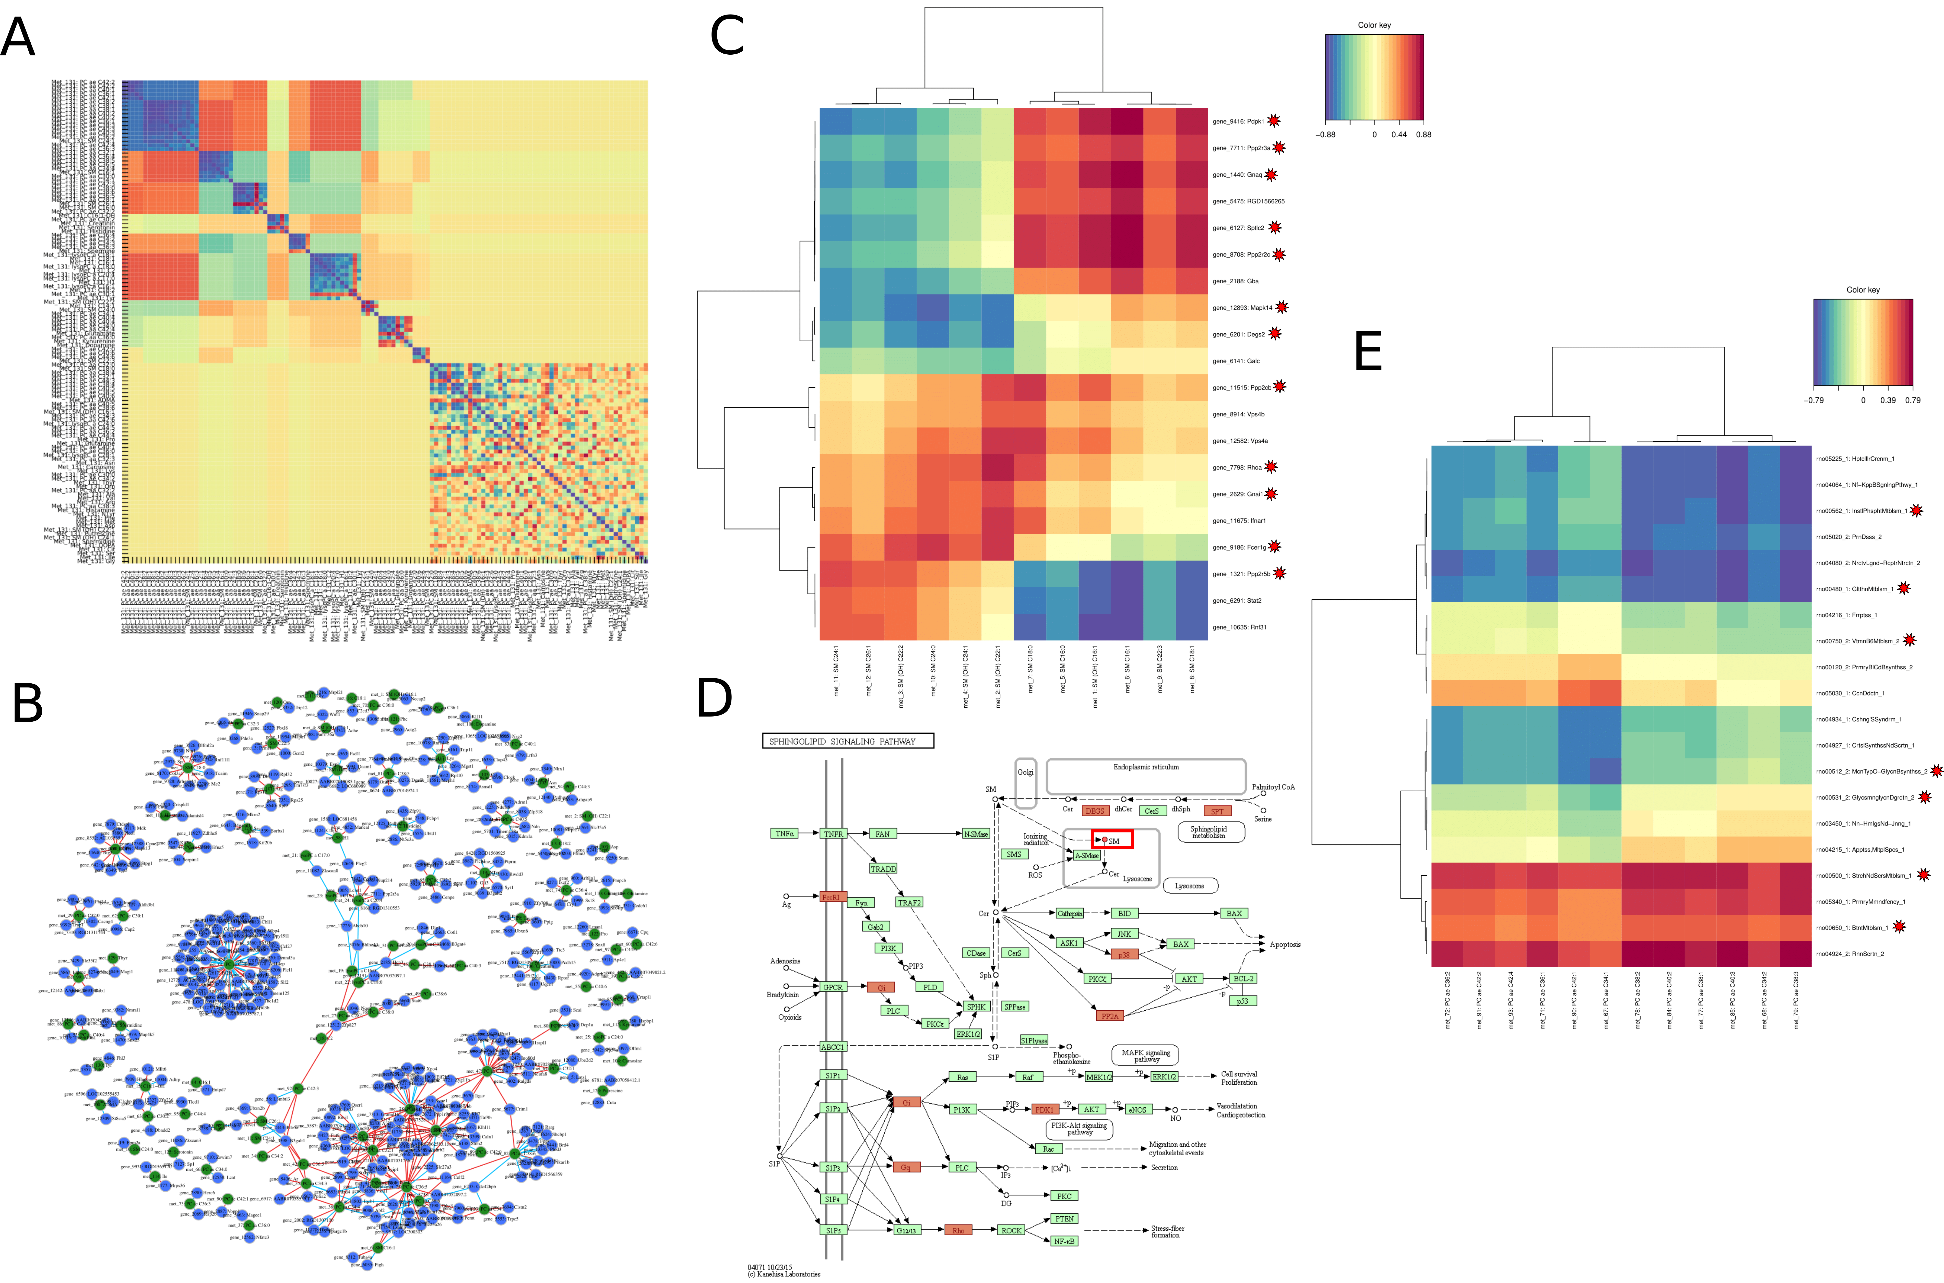

Supplemental Figure 2: Graphical Output. Panel A shows the output of a Modulated Modularity Clustering (MMC) Analysis (Stone and Ayroles 2009). A smooth correlation ordering is performed on a rat dataset in order to differentiate blocks of metabolites with the same behavior. Metabolites were grouped into 11 different blocks, with the last block containing all metabolites that were not grouped into a module. Blue is positively correlated and red is negatively correlated. Panel B shows a typical output of the Gene/Metabolite Correlation Tool. Metabolites are represented in green, while genes are represented in blue. Red lines represent positive correlations and light blue lines signify negative correlations. The largest node shows a correlation between Phosphatidylcholine (PC aa C30:0) and 24 genes. Panel C shows the generation of a heatmap after a sparse PLS (sPLS) Analysis is performed with the Gene/Metabolite Integration Tool. With this analysis, it is possible to differentiate between short and long chain Sphingomyelins. Genes marked with a red star reappear in Panel D, which is the representation of the KEGG ‘Sphingolipid Signaling Pathway’. The red box highlights the metabolite ‘Sphingomyelin’. Panel E shows the integration of Eigengenes with the first MMC Module of Phosphatidylcholines using the Gene/Metabolite Integration Tool. Here metagenes estimated from the PANA approach are marked with a red star are related to Metabolic Pathways.
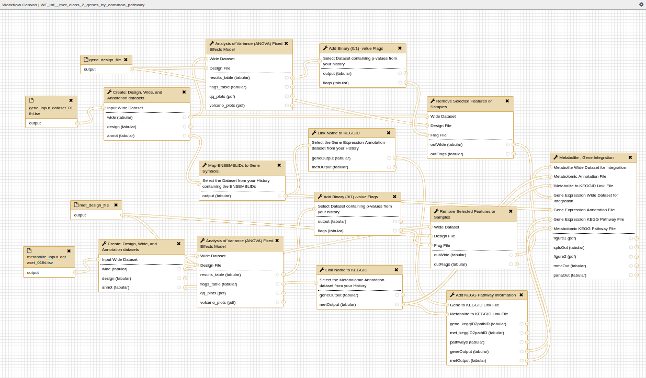

Supplemental Figure 3: Example of a Metabolite – gene integration Galaxy workflow. The workflow starts with the input of gene expression and metabolite abundance data. Annotation to KEGG is performed for both input data sets. ANOVA analyses are performed and features significant at a nominal level are selected for further analyses. Integration using MMC for metabolites and PANA for gene expression is performed.

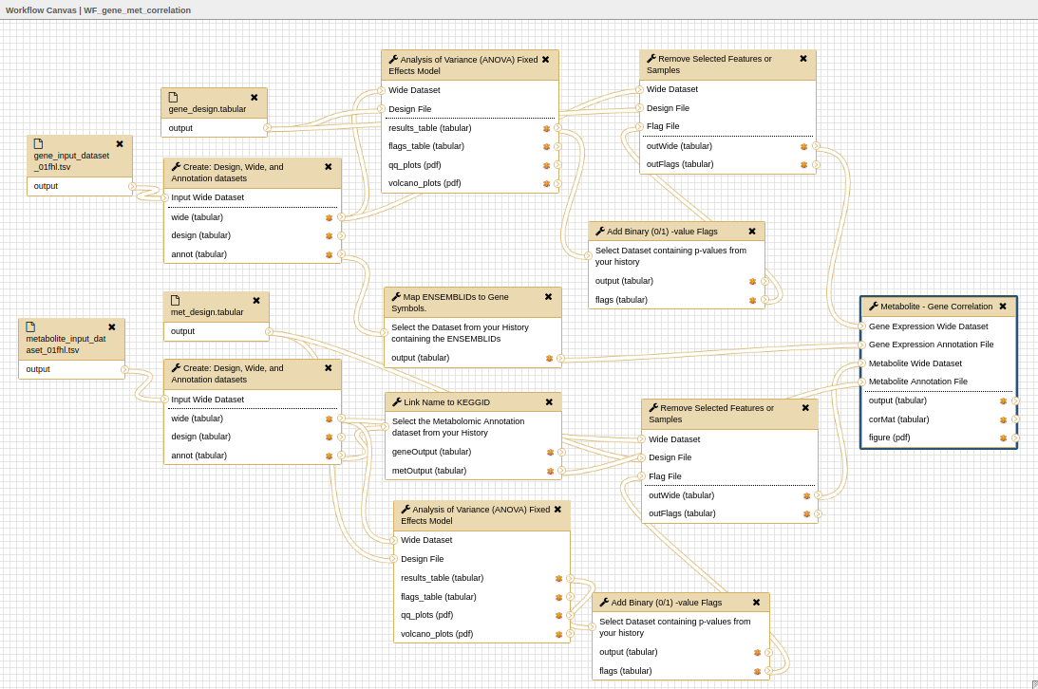

Supplemental Figure 4: Metabolite – gene correlation Galaxy workflow. The workflow starts with the input of gene expression and metabolite abundance data. Annotation to KEGG is performed for both input data sets. ANOVA analyses are performed and features significant at a nominal level are selected for further analyses. All pairwise correlations between metabolite abundances and gene expression values are performed.

We have leveraged the power of the Galaxy platform, and the existing contributions of the community to create complete Galaxy workflows for the integrated analysis of gene and metabolite expression data. Several example workflows are available on github (https://github.com/secimTools/gait-gm​). Starting with data files and feature identification information (e.g. m/z ratios or retention times), the 'WF_int_met_class_2-genes_by_common_pathway' Galaxy workflow (Suppl. Figure 3) will create wide format datasets, design files, identify the genes and metabolites of interest by ANOVA, annotate the genes and metabolites via KEGG and integrate the gene expression and metabolite data by modeling metabolite classes as a function of the genes in the metabolite pathways. We recommend that both gene expression and metabolite datasets be reduced to reflect a common biological hypothesis before running this tool. In another example workflow (Supplementary Figure 4), metabolite data are subset by class (i.e. using the 'Name_in_KEGG' column generated from the 'Link Name to KEGGID' tool) and only the genes found in the common metabolite pathways are selected for the integration step, here as an unbiased correlation between pairs of genes and metabolites that share a common pathway.

Additional example Galaxy workflows are available (https://github.com/secimTools/gait-gm​). The 'WF_int_met_2_metagene.ga' workflow contains the same tools as described above but the options chosen in the 'Metabolite – Gene Integration' tool are different. In this case, the options select model metabolite classes as a function of metagenes where the gene expression data is reduced in scope by implementation of PANA (Ponzoni et al. 2014). To include similarly behaving metabolites without regard to identification or type, the 'WF_int_MMC_2_metagene.ga' Galaxy workflow options implement the MMC tool to estimate modules that are modeled as a function of metagenes

The 'WF_gene_met_correlation' Galaxy workflow (Suppl. Figure 4) creates wide format datasets, design files, identifies the genes and metabolites of interest by ANOVA, annotates the genes and metabolites via KEGG and performs a correlation analysis between significant genes and metabolites to generate a table of correlation coefficients. P-values for the correlation coefficients are calculated by simulating individual gene and metabolite datasets 1000 times using a normal distribution with means and standard deviations generated from the data. Sample size reflects the input datasets. Correlations are calculated on the simulated data. Correlations must be higher/lower than 95% of the randomly simulated values to be considered significant.

Stone, E. A. & J. F. Ayroles (2009) Modulated Modularity Clustering as an Exploratory Tool for Functional Genomic Inference. Plos Genetics, 5.

